Research Format Guidelines
First: Margins and Layout
The top, bottom, right margin, and left margin are formatted as shown in the image. The value of each margin that needs to be entered is shown in centimeters.
- The Page Setup can be accessed by clicking on Layout menu, then on Margins, and then choosing Custom Margins, etc.
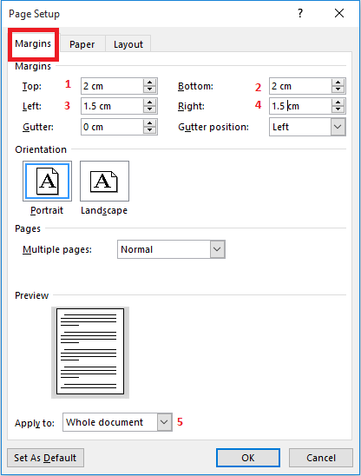
Margins:
Steps 1 to 5: Apply all steps then click ”OK”.
Layout:
Step 6 to 8: Apply all steps then click ”OK”.

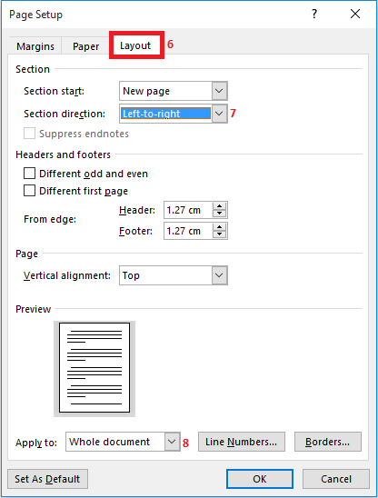

Second: Cover of the Research (first page of the research)
- Title of the Research
The title of the research is written at the beginning of the page according to the following format:
- Font size: 36, Bold
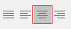
- Font Type: Times New Roman
- Alignment: Center

- Name of the Researcher
The name of the researcher is written in the center of the page according to the following format:
- Font size: 24, Bold
- Font Type: Times New Roman
- Alignment: Center
Third: Content of the Research
- Margins Adjustment of the Research Content Pages and Columns
- The pages are divided into two columns according to the format shown in the image.
- Follow the numbers shown in the image and enter the same values for each stage as shown in the image.

- Columns are accessed by choosing the Layout menu, then clicking on Columns and finally choosing More Columns, etc.
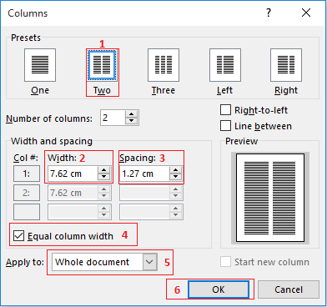

- Headings and Texts
The headings, subheadings and texts in the research are formatted according to the following:
- Main Heading
- Font size: 16, Bold
- Font type: Times New Roman
- Alignment: left

- Subheading
- Font size: 13, Bold
- Font type: Times New Roman
- Alignment: left

- Sub-Subheading
- Font size: 13, Bold
- Font type: Times New Roman
- Alignment: left

- Texts
- Font size: 12
- Font type: Times New Roman
- Alignment: Justify
Note: Original Arabic numerals (1234567890) should be used. Follow the instructions to learn how to set the program to use Arabic numerals.
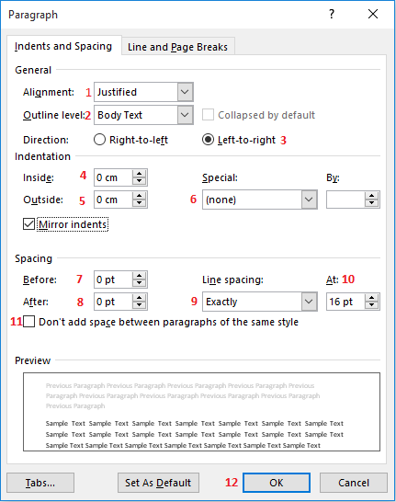

- Paragraph Format

- Shade the paragraph you want to format.
- Hover the pointer over the highlighted paragraph and right-click the mouse, then choose Paragraph.
- Follow the steps as shown in the following image:

Fourth: Inserting Tables
- Small table with two column formatting

- Choose the column in which you want to insert a table, whether the right or left column, by placing the pointer on a new line as shown in the image:
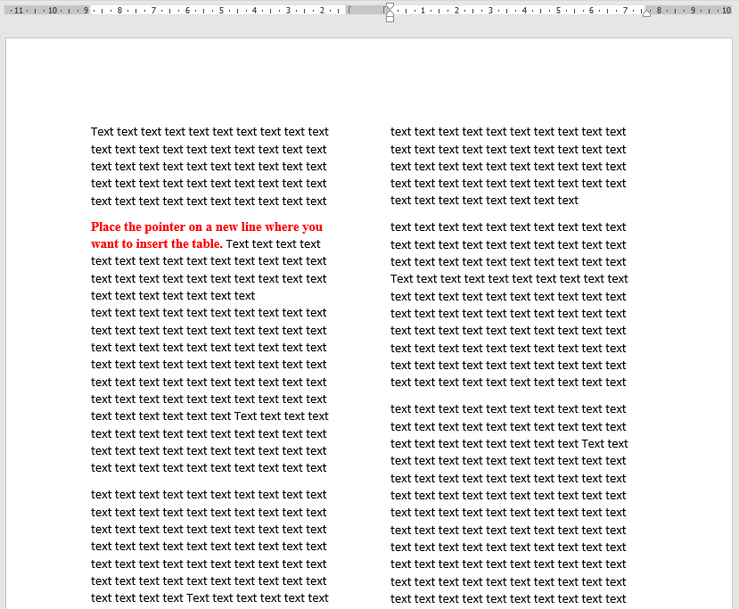
- From the Insert menu, choose Table, and then select the number of columns and rows for the table as shown in the image. The image shows a table consisting of four columns and four rows as per the shaded cells in the image.
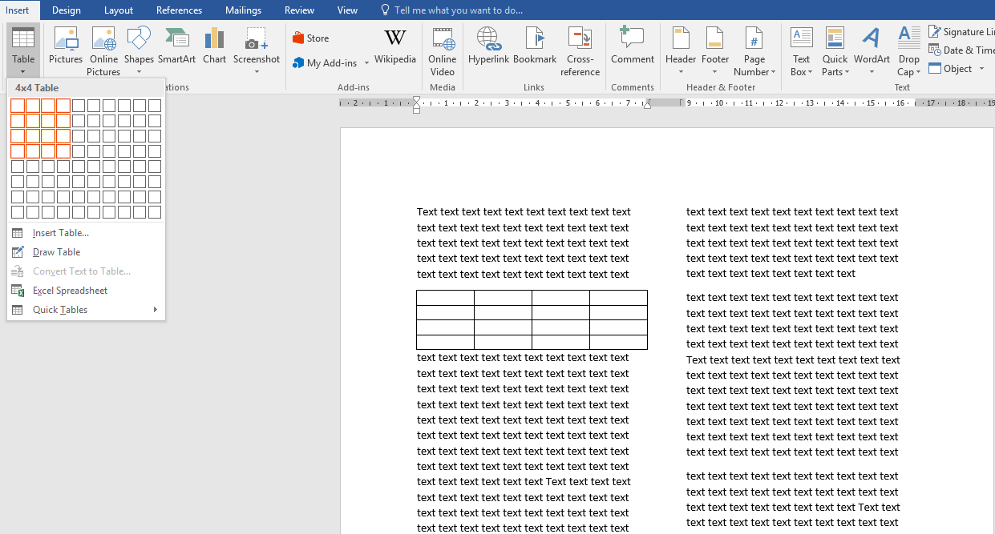
- The result is a table consisting of four rows and four columns as shown in the following image:

- Large table or picture crossing two columns

- Insert the table as in the previous method.

- Click on the table to shade it completely
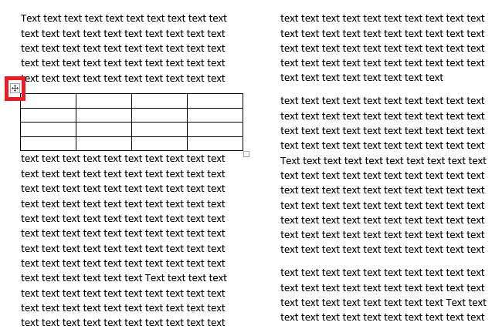
Click on the table move handle to select the entire table

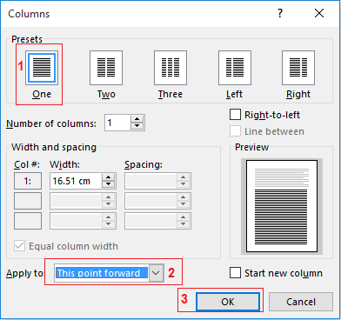
- From the Layout menu, click on Columns, choose More Columns, and specify the information as shown in the following image:

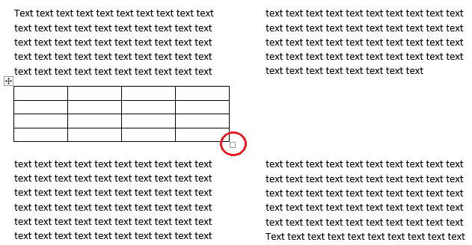
- The result appears as in the following image:

Click on the resize handle to expand the entire table

- After expanding the table, it appears as follows:
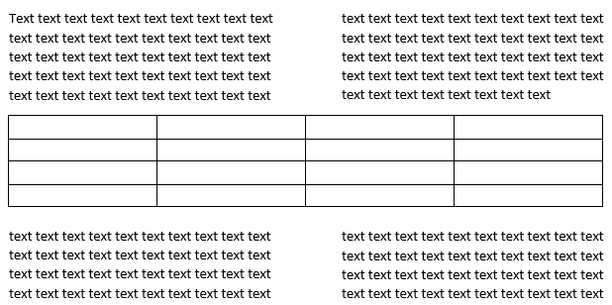

To insert an image or text in the same way that the table appears, apply the same steps to the image or text, starting by clicking on the image to select it or shading the text, and then applying the steps shown in the image in step 3.
Fifth: Table Formatting
Format the title of the table as follows:
- Table Number
- Use the phrase “Table #” to number the table by inserting the table number instead of the symbol #
- Font size: 10 Bold
- Font type: Times New Roman
- Alignment: center

- Table Title
- The table title is placed below the table number.
- Font size: 10 Bold
- Font type: Times New Roman
- Alignment: center

- Table Rows/Columns Titles
- Font size: 10 Bold
- Font type: Times New Roman

- Text Inside the Table
- Font size: 10
- Font type: Times New Roman

- Table Limits
Choosing the Top and Bottom Borders for the table is achieved by doing the following steps:
- Shade the table.
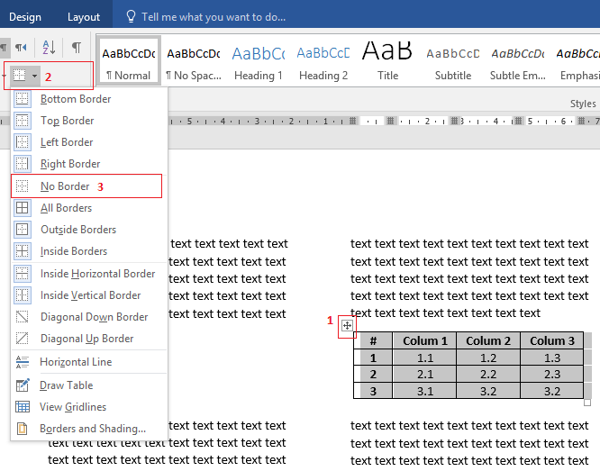
- From the Home menu, click on Borders as shown and choose No Border as shown in the following image:

- Go back to the table borders drop list as explained in step 2 and choose Bottom Border.

- Repeat the previous step 4 and then choose Top Border.
The final table format within one column space
